Lab #1 intro Practice Problems
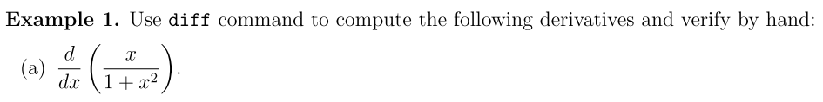
>> syms x %define symbolic variables

>> diff(x/(1+x^2))
% diff(x/(1+x^2),x)
% diff(x/(1+x^2),x,1)

ans =

1/(x^2 + 1) - (2*x^2)/(x^2 + 1)^2

>> simplify(diff(x/(1+x^2))) %simplify the result

ans =

-(x^2 - 1)/(x^2 + 1)^2

%%--------------------------------------

>> diff(log(sin(x)))

ans =

cos(x)/sin(x)

>> simplify(ans)

ans =

cot(x)

%%--------------------------------------

>> diff(exp(3*x),2)
%diff(exp(3*x),x,2)

ans =

9*exp(3*x)

clc %Clear command window
clear all %removes all variables, globals, functions and MEX links

%int(S) or int(S,v) for indefinite integral, int(S,a,b) or int(S,v,a,b) for definite integral

>> syms x
>> int(1/(x*(1-x)))
%int(1/(x*(1-x)),x)

ans =

-log(1 - 1/x)

%%--------------------------------------

>> int(exp(x)*sin(x))

ans =

-(exp(x)*(cos(x) - sin(x)))/2

%%--------------------------------------

>> int(abs(sin(x)),x,0,pi)

ans =

2

clc %Clear command window
clear all %removes all variables, globals, functions and MEX links

>> syms x
>> solve(x^3-5*x^2+6*x-2==0)
%vpasolve(x^3-5*x^2+6*x-2==0)
%fzero(@(x) x^3-5*x^2+6*x-2,0.5)

ans =

1
2^(1/2) + 2
2 - 2^(1/2)

%%--------------------------------------

>> solve(x==cos(x))

ans =

0.73908513321516064165531208767387

%%--------------------------------------

>> syms x y
>> [Sx Sy]=solve(3*x+2*y==8,x-3*y==-1)

Sx =

2

Sy =

1

%%--------------------------------------

>> syms x y
>> [Sx,Sy]=solve(x^2-y^2==1,2*x+y==2)

Sx =

1
5/3

Sy =

0
-4/3

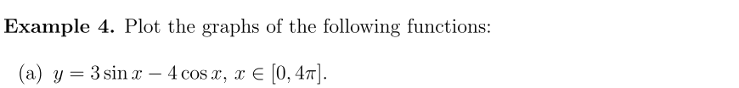
clc
clear all

>> x=0:0.1:4*pi; %semicolon: the command is executed but the result is not displayed
>> y=3*sin(x)-4*cos(x);
>> plot(x,y,'r-','linewidth',2.5)
hold on
axis([0,4*pi,-6,6]) %Control axis scaling and appearance.
xlabel('x'); ylabel('y');
hold off

%fplot(@(x) 3*sin(x)-4*cos(x),[0,4*pi]) %define an anonymous function of x
%ezplot('3*sin(x)-4*cos(x)',[0,4*pi])

%syms x
%ezplot(3*sin(x)-4*cos(x),[0,4*pi])
%%--------------------------------------

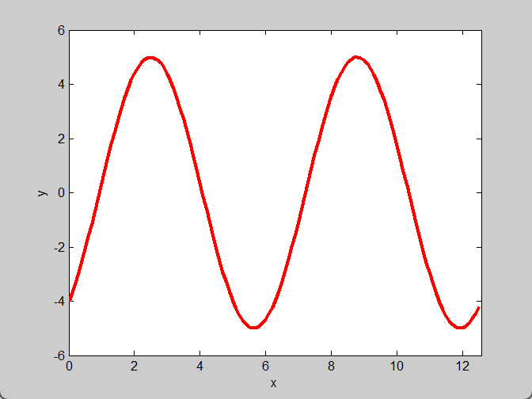
%%--------------------------------------
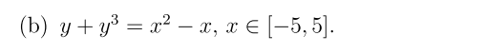
>> syms x y
>> ezplot(y+y^3==x^2-x,[-5,5,-1,5]) %an implicit function

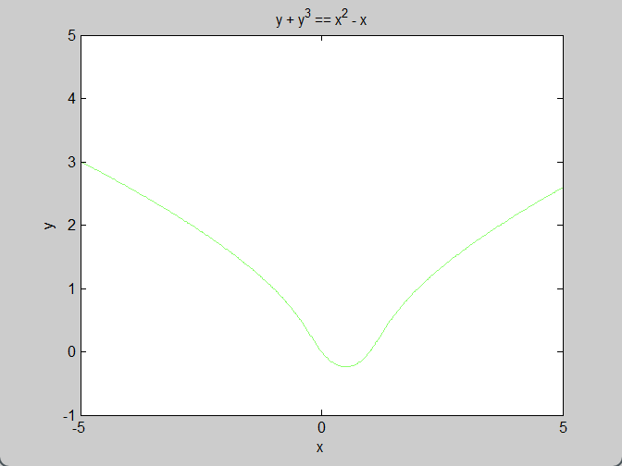
%%--------------------------------------
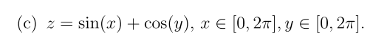

>> close all
>> [X,Y] = meshgrid(0:0.5:2*pi,0:0.1:2*pi); % produce the coordinates of a rectangular grid
Z = sin(X) + cos(Y);
surf(X,Y,Z)





